Project Design Phase-II
Data Flow Diagram & User Stories

Date | 04 October 2026
Team ID | 10
Project Name | Import Data using Transform Maps (Spreadsheet)
Maximum Marks | 4 Marks

Data Flow Diagrams:
A Data Flow Diagram (DFD) is a traditional visual representation of the information flows within a system. A neat and clear DFD can depict the right amount of the system requirement graphically. It shows how data enters and leaves the system, what changes the information, and where data is stored.
DFD Level 0: Import Data using Transform Maps
Data Flow Diagram (Level 0):
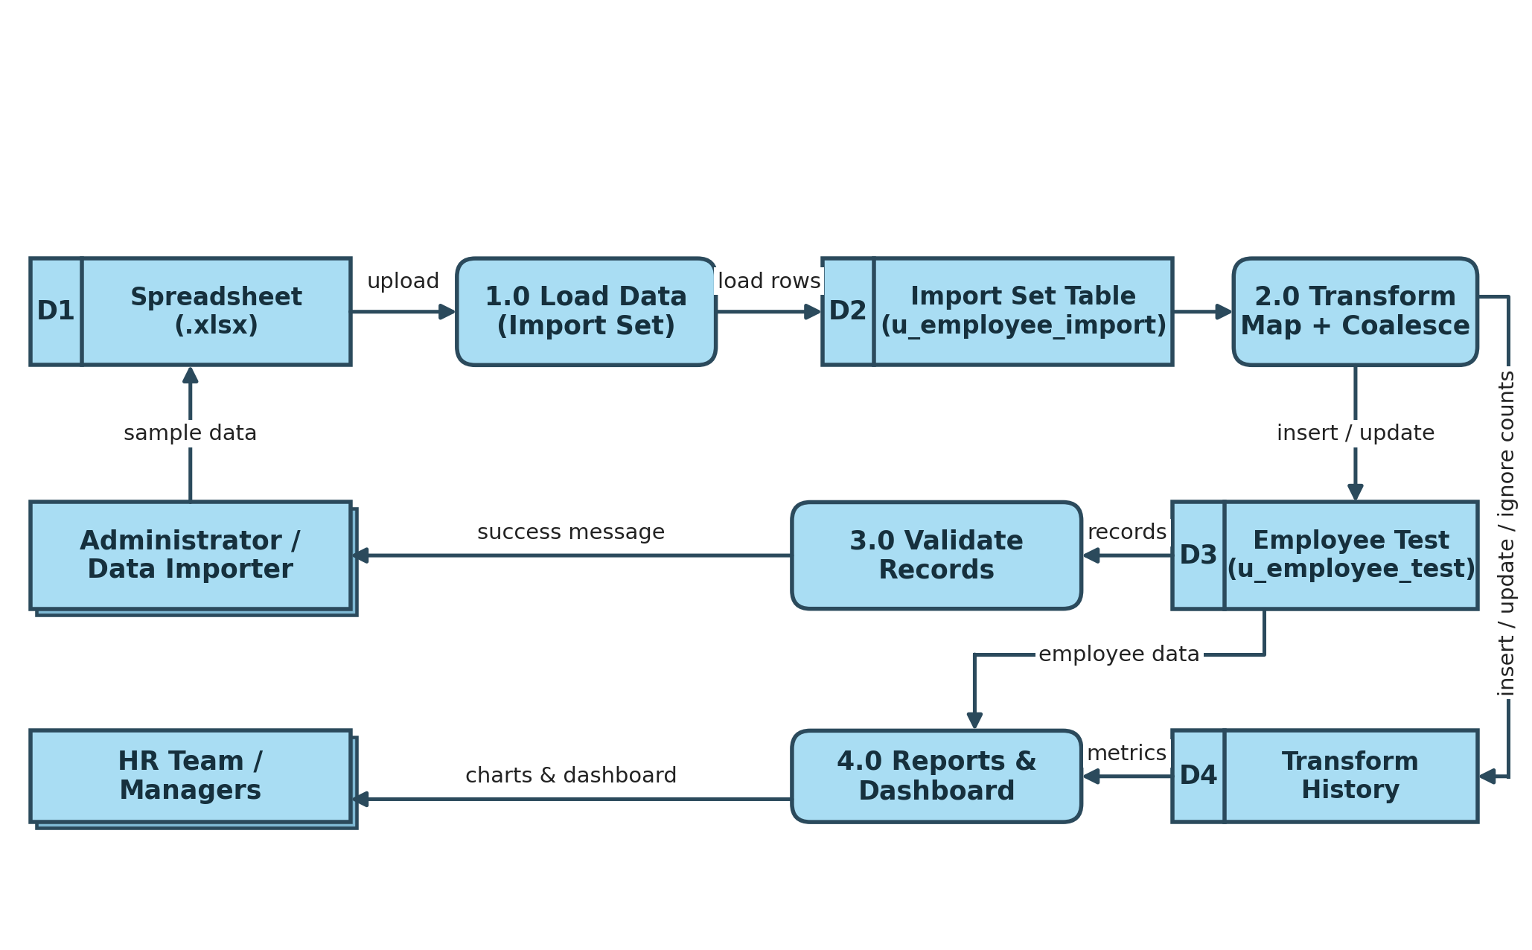
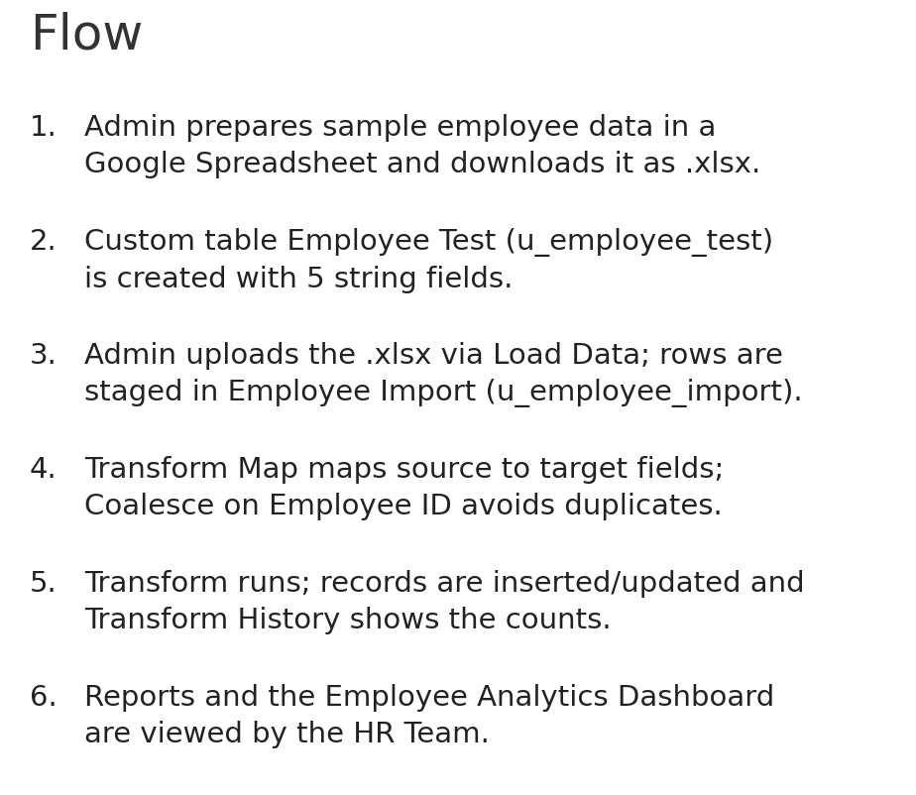

User Stories
Use the below template to list all the user stories for the product.
User Type | Functional Requirement (Epic) | User Story Number | User Story / Task | Acceptance criteria | Priority | Release
Administrator / Data Importer | Prepare Source Data | USN-1 | As an administrator, I can create a Google Spreadsheet with sample employee data (Employee ID, Name, Email, Department, Location) and download it as Sample Spreadsheet.xlsx. | I can download the .xlsx file with all employee records and columns | High | Sprint-1
 | Create Custom Table | USN-2 | As an administrator, I can create a custom table Employee Test (u_employee_test) in ServiceNow. | The table is created and saved successfully | High | Sprint-1
 |  | USN-3 | As an administrator, I can add the fields Employee ID, Employee Name, Email, Department and Location (String) to the Employee Test form. | All five fields appear on the Employee Test form | High | Sprint-1
 | Load Data (Import Set) | USN-4 | As an administrator, I can load the .xlsx file using Load Data to create the Import Set table Employee Import (u_employee_import). | The file is uploaded and rows are staged in the Import Set table | High | Sprint-1
 |  | USN-5 | As an administrator, I receive a success message after submitting the import so that I can proceed to create the Transform Map. | Success message is displayed and Create Transform Map option is available | Medium | Sprint-1
 | Transform Map | USN-6 | As an administrator, I can create a Transform Map (Sample Spreadsheet Import) from Employee Import to Employee Test and map the matching fields using Auto Map / Mapping Assist. | All source and target fields are mapped and the map is saved | High | Sprint-2
 |  | USN-7 | As an administrator, I can run the transform so that staged records are created in the target table. | Transform completes with a success message | High | Sprint-2
 | Validate Data | USN-8 | As an administrator, I can open the Employee Test table and verify the imported records. | All spreadsheet records are visible with correct field values | High | Sprint-2
 | Coalesce (Avoid Duplicates) | USN-9 | As an administrator, I can enable Coalesce on the Employee ID field map so that duplicate employee records are not created. | Coalesce is set to true on Employee ID and the map is saved | High | Sprint-3
 |  | USN-10 | As an administrator, I can re-import a modified spreadsheet and view Transform History so that I can confirm which rows were inserted, updated or ignored. | Existing IDs are updated, new IDs are inserted and unchanged rows are ignored (e.g., 2 inserted, 2 updated; repeat import: 4 ignored) | High | Sprint-3
 | Reports | USN-11 | As an administrator, I can create reports on the Employee Test table: Employees by Department (Pie), Employees by Location (Bar) and Employee List Report (List). | All three reports run and are saved successfully | Medium | Sprint-3
 | Dashboard | USN-12 | As an administrator, I can create the Employee Analytics Dashboards and add the three reports to it. | The dashboard displays all three reports | Medium | Sprint-3
HR Team Member | Dashboard | USN-13 | As an HR team member, I can view the Employee Analytics Dashboards to monitor department-wise and location-wise employee distribution. | I can open the dashboard and see the charts and list report | Medium | Sprint-3

